Supplementary Table S1. Overview of the number of larvae captured during the monitoring events from 2019 to 2021. In 2019, five ponds and five streams were monitored regularly, but the monitoring was started later for KoVK and TT (indicated by “-“). In 2020 and 2021, only four ponds and five streams were monitored, as the puddle MP, classified as a pond, was completely desiccated. Asterisks mark sample sites that were desiccated at the respective monitoring event. The maximum number of captured larvae per sample sites in a respective year is in bold.

Monitoring | date | KoB | VB | AB | KB | MB | SG | TG | MP | KoVK | TT | WT
2019-1 | 27.-31.03.19 | 11 | 20 | 0 | 19 | 35 | 11 | 1 | 34 | - | - | -
2019-2 | 04.-05.04.19 | 25 | 33 | 1 | 22 | 41 | 14 | 10 | 76 | 47 | - | -
2019-3 | 11.-12.04.19 | 13 | 60 | 1 | 16 | 52 | 9 | 6 | 72 | 35 | - | -
2019-4 | 18.-20.04.19 | 24 | 68 | 5 | 32 | 49 | 14 | 12 | 75 | 54 | 46 | -
2019-5 | 25.-27.04.19 | 19 | 86 | 11 | 30 | 65 | 38 | 10 | 90 | 38 | 49 | -
2019-6 | 02.-04.05.19 | 2 | 86 | 8 | 36 | 57 | 25 | 13 | 98 | 33 | 40 | -
2019-7 | 09.-11.05.19 | 15 | 90 | 8 | 39 | 39 | 27 | 1 | 80 | 34 | 52 | -
2019-8 | 15.-17.05.19 | 10 | 84 | 5 | 29 | 12 | 39 | 13 | 76 | 53 | 46 | -
2019-9 | 18.-19.06.19 | * | 41 | * | 22 | 4 | * | * | 36 | 36 | 34 | -
2019-10 | 30.-31.07.19 | * | 11 | * | 3 | 0 | * | * | * | 5 | 0 | -
2020-1 | 21.-22.04.20 | 13 | 21 | 0 | 51 | 30 | * | * | * | 60 | 54 | -
2020-2 | 25.-27.05.20 | 18 | 24 | * | 27 | 17 | * | * | * | 41 | * | -
2020-3 | 29.-30.06.20 | 12 | 15 | * | 10 | 3 | * | * | * | 10 | * | -
2021-1 | 15.-17.03.21 | 3 | 1 | 0 | 12 | 3 | 3 | 5 | * | 33 | 4 | -
2021-2 | 22.-23.03.21 | 1 | 2 | 0 | 31 | 4 | 6 | 6 | * | 15 | 9 | -
2021-3 | 29.-31.03.21 | 6 | 5 | 0 | 23 | 24 | 2 | 9 | * | 21 | 16 | -
2021-4 | 05.-07.04.21 | 8 | 6 | 0 | 37 | 17 | 9 | 13 | * | 24 | 45 | -
2021-5 | 12.-13.04.21 | 3 | 3 | 0 | 28 | 34 | 8 | 4 | * | 22 | 17 | -
2021-6 | 19.-20.04.21 | 8 | 23 | 0 | 37 | 24 | 6 | 7 | * | 51 | 41 | -
2021-7 | 26.-27.04.21 | 28 | 12 | 0 | 39 | 18 | 6 | 3 | * | 35 | 34 | -
2021-8 | 03.-04.05.21 | 20 | 19 | 0 | 47 | 25 | 5 | * | * | 29 | 19 | -
2021-9 | 29.-30.05.21 | 17 | 35 | * | 12 | 33 | 0 | 0 | * | 20 | 38 | -
2021-10 | 28.-29.06.21 | * | 24 | * | 17 | 16 | * | * | * | 33 | 46 | -
2021-11 | 26.-27.07.21 | 0 | 27 | 0 | 7 | 0 | 0 | * | * | 28 | 22 | -
2021-12 | 26.08.21 | * | 0 | 0 | 0 | 0 | 0 | 0 | * | 0 | 3 | -
2021-13 | 27.09.21 | * | 1 | * | 0 | 0 | * | * | * | 0 | 0 | -
2021-14 | 26.10.21 | * | 0 | * | 0 | 0 | 0 | * | * | 2 | * | -
2021-15 | 06.12.21 | 0 | 0 | 0 | 0 | 0 | 0 | 0 | * | 0 | * | -
2022-1 | 26.-27.01.22 | 1 | 0 | - | 1 | 1 | * | 0 | * | 10 | 12 | -
2022-2 | 22.-23.02.22 | 0 | 1 | - | 10 | 4 | 4 | 12 | * | 14 | 10 | -
2022-3 | 15.-16.03.22 | 0 | 8 | - | 12 | 15 | 3 | * | * | 21 | 15 | -
2022-4 | 21.-23.03.22 | 5 | 8 | - | 18 | 12 | 2 | * | * | 15 | 16 | 70
2022-5 | 28.-29.03.22 | 7 | 6 | - | 11 | 8 | 1 | * | * | 10 | 19 | 25
2022-6 | 04.-06.04.22 | 8 | 12 | - | 22 | 9 | 0 | * | * | 2 | 25 | 41
2022-7 | 11.-12.04.22 | 5 | 19 | - | 41 | 17 | 2 | * | * | 0 | 23 | 47
2022-8 | 18.-19.04.22 | 11 | 14 | - | 66 | 19 | 1 | * | * | 6 | 39 | 54
2022-9 | 24.-26.04.22 | 8 | 12 | - | 32 | 16 | 2 | * | * | 3 | 32 | 37
2022-10 | 02.-04.05.22 | 21 | 20 | - | 46 | 18 | 11 | * | * | 3 | 58 | 59
2022-11 | 09.-10.05.22 | 30 | 27 | - | 46 | 20 | 3 | * | * | 0 | 55 | 189
2022-12 | 29.-30.05.22 | 22 | 27 | - | 33 | 20 | 0 | * | * | 8 | 51 | 122
2022-13 | 07.-08.07.22 | * | 2 | - | 0 | 3 | * | * | * | 14 | * | 96
2022-14 | 08.08.22 | * | 1 | - | 0 | 0 | * | * | * | * | * | *
2022-15 | 12.-13.09.22 | * | 0 | - | 0 | 0 | * | * | * | * | * | *

Supplementary Table S2. Overview of the Bsal samples from 2019 to 2022.

Stage | Location | 2019 |  | 2020 |  | 2021 |  | 2022
 |  | date | samples | date | samples | date | samples | date | samples
Larvae | KoB | 29.03.2019 | 5 | 22.04.2020 | 10 | 15.03.2021  22.03.2021  29.03.2021 | 3  1  1 | 21.03.2022 | 5
 | VB | 28.03.2019 | 5 | 22.04.2020 | 10 | 17.03.2021  23.03.2021  30.03.2021 | 1  2  2 | 16.03.2022  21.03.2022 | 16  8
 | AB | - | - | - | - | - | - | - | -
 | KB | 27.03.2019 | 5 | 29.06.2020 | 10 | 16.03.2021 | 5 | 15.03.2022  21.03.2022  29.03.2022  06.04.2022  18.04.2022  25.04.2022 | 24  18  11  15  35  9
 | MB | 30.03.2019 | 5 | 22.04.2020 | 10 | 17.03.2021  23.03.2021 | 3  2 | 16.03.2022  29.03.2022  05.04.2022  18.04.2022  25.04.2022 | 10  8  18  19  16
 | SG | 28.03.2019 | 5 | - | - | 16.03.2021  22.03.2021 | 3  2 | 22.03.2022  28.03.2022  04.04.2022  19.04.2022  26.04.2022 | 2  1  1  1  1
 | TG | 28.03.2019  04.04.2019 | 1  4 | - | - | 16.03.2021 | 5 | - | -
 | MP | 31.03.2019 | 5 | - | - | - | - | - | -
 | KoVK | 05.04.2019 | 5 | 22.04.2020 | 10 | 15.03.2021 | 5 | 15.03.2022 | 10
 | TT | 20.04.2019 | 5 | - | - | 16.03.2021  22.03.2021 | 4  1 | 16.03.2022  22.03.2022  04.04.2022  11.04.2022  19.04.2022 | 27  16  25  10  35
 | WT | - | - | - | - | - | - | 23.03.2022  05.04.2022  12.04.2022  19.04.2022 | 26  41  23  10
Adults | Kottenforst | 02.04.2019  03.04.2019  08.04.2019  09.04.2019  17.04.2019 | 1  10  1  6  2 | - | - | 23.03.2021  25.03.2021  26.03.2021  28.03.2021  29.03.2021 | 1  8  5  2  4 | 16.03.2022  31.03.2022  04.04.2022  05.04.2022  06.04.2022  30.05.2022 | 10  10  2  7  8  15

Supplementary Table S3. Results of the tests for normal distribution (Shapiro-Wilk test) and variance of homogeneity (F-test or Fligner test) for all investigated variables. If not stated otherwise these results refer to the difference between the two habitats pond and stream. The Fligner test is indicated by an asterisk and was performed in case of non-normal distribution. The column “Transformation” indicates, whether the variables were not transformed (“raw”) or transformed (e.g., “ordernorm” and “centerscale”). Significant values are in bold and indicate non-normality and non-homogeneity of variances, respectively.

 |  |  | Shapiro-Wilk test |  | Variance test
Variable | Transformation | W |  | p |  | F/Chi²* | p
Water temperature | raw | 0.974 |  | 0.002 |  | 0.304* | 0.581*
 | ordernorm | 0.999 |  | 1 |  | 1.170 | 0.457
Number of observed larvae | raw | 0.827 |  | < 0.001 |  | 5.653* | 0.017*
 | ordernorm | 0.992 |  | 0.321 |  | 1.560 | 0.031
Mean larval size | raw | 0.923 |  | < 0.001 |  | 0.011* | 0.917*
 | ordernorm | 1 |  | 1 |  | 0.811 | 0.318
Individual daily growth | raw | 0.753 |  | < 0.001 |  | 13.467* | < 0.001*
 | ordernorm | 0.999 |  | 0.999 |  | 0.615 | < 0.001
Percentage of injured larvae | raw | 0.742 |  | < 0.001 |  | 0.551* | 0.458*
 | ordernorm | 0.911 |  | < 0.001 |  | 4.904* | 0.027*
Recapture rate | raw | 0.816 |  | < 0.001 |  | 1.939* | 0.164*
 | centerscale | 0.816 |  | < 0.001 |  | 1.939* | 0.164*
Survival rates | raw | 0.758 |  | < 0.001 |  | 1.009* | 0.315*
 | ordernorm | 0.947 |  | < 0.001 |  | 1.009* | 0.315*
Estimated population size | raw | 0.827 |  | < 0.001 |  | 0.072* | 0.789*
 | ordernorm | 0.998 |  | 1 |  | 0.607 | 0.069

Supplementary Table S4. Number of recaptures among captured animals and recapture rates per sample site based on the monitoring events in 2021. Given are the number of recaptures and the number of captured animals during a specific monitoring event. Values in brackets represent the corresponding recapture rate calculated as the number of recaptures divided by the number of captured animals. Estimations were only possible for four streams and four ponds. Two sample sites that have been used in previous years were excluded from the analysis, since one pond (puddle MP) was desiccated and one stream section (AB) did not contain any larvae. Some monitoring events were excluded from the analysis of specific sample sites, because we did not find any larvae there (indicated by “-“). Asterisks mark sample sites that were desiccated at the respective monitoring event. The maximum recapture rate per sample site is in bold.

Monitoring | date | KoB | VB | KB | MB | SG | TG | KoVK | TT
2021-1 | 15.-17.03.21 | 0/3 (0) | 0/1 (0) | 0/12 (0) | 0/3 (0) | 0/3 (0) | 0/5 (0) | 0/33 (0) | 0/4 (0)
2021-2 | 22.-23.03.21 | 0/1 (0) | 0/2 (0) | 0/31 (0) | 0/4 (0) | 0/6 (0) | 0/6 (0) | 1/15 (6.67) | 0/9 (0)
2021-3 | 29.-31.03.21 | 0/6 (0) | 0/5 (0) | 2/23 (8.70) | 1/24 (4.17) | 1/2 (50.00) | 0/9 (0) | 2/21 (9.52) | 0/16 (0)
2021-4 | 05.-07.04.21 | 1/8 (12.50) | 0/6 (0) | 6/37 (16.22) | 0/17 (0) | 0/9 (0) | 1/13 (7.69) | 3/24 (12.50) | 0/45 (0)
2021-5 | 12.-13.04.21 | 0/3 (0) | 0/3 (0) | 3/28 (10.71) | 5/34 (14.71) | 2/8 (25) | 1/4 (25.00) | 3/22 (13.64) | 0/17 (0)
2021-6 | 19.-20.04.21 | 1/8 (12.50) | 1/23 (4.35) | 7/37 (18.92) | 2/24 (8.33) | 1/6 (16.67) | 3/7 (42.86) | 11/51 (21.57) | 0/41 (0)
2021-7 | 26.-27.04.21 | 9/28 (32.14) | 2/12 (16.67) | 8/39 (20.51) | 2/18 (11.11) | 2/6 (33.33) | 1/3 (33.33) | 8/35 (22.86) | 2/34 (5.88)
2021-8 | 03.-04.05.21 | 6/20 (30.00) | 3/19 (15.79) | 16/47 (34.04) | 2/25 (8.00) | 0/5 (0) | * | 7/29 (24.14) | 2/19 (10.53)
2021-9 | 29.-30.05.21 | 6/17 (35.29) | 3/35 (8.57) | 3/12 (25.00) | 1/33 (3.03) | - | - | 3/20 (15.00) | 2/38 (5.26)
2021-10 | 28.-29.06.21 | * | 1/24 (4.17) | 2/17 (11.76) | 1/16 (6.25) | * | * | 6/33 (18.18) | 4/46 (8.70)
2021-11 | 26.-27.07.21 | - | 2/27 (7.41) | 0/7 (0) | - | - | * | 5/28 (17.86) | 3/22 (13.64)
2021-12 | 26.08.21 | * | - | - | - | - | - | - | 0/3 (0)
2021-13 | 27.09.21 | * | 1/1 (100.00) | - | - | * | * | - | -
2021-14 | 26.10.21 | * | - | - | - | - | * | 0/2 (0) | *
2021-15 | 06.12.21 | - | - | - | - | - | - | - | *

Supplementary Table S5. Number of recaptures among captured animals and recapture rates per sample site based on the monitoring events in 2022. Given are the number of recaptures and the number of captured animals during a specific monitoring event. Values in brackets represent the corresponding recapture rate calculated as the number of recaptures divided by the number of captured animals. Estimations were only possible for four streams and four ponds. Two sample sites that have been used in previous years were excluded from the analysis, since one pond (puddle MP) was desiccated and one stream section (AB) did not contain any larvae. Some monitoring events were excluded from the analysis of specific sample sites, because we did not find any larvae there (indicated by “-“). Asterisks mark sample sites that were desiccated at the respective monitoring event. The maximum recapture rate per sample site is in bold.

Monitoring | date | KoB | VB | KB | MB | SG | WT | KoVK | TT
2022-1 | 26.-27.01.22 | 0/1 (0) | - | 0/1 (0) | 0/1 (0) | * | - | 0/10 (0) | 0/12 (0)
2022-2 | 22.-23.02.22 | - | 0/1 (0) | 0/10 (0) | 0/4 (0) | 0/4 (0) | - | 1/14 (7.14) | 0/10 (0)
2022-3 | 15.-16.03.22 | - | 0/8 (0) | 0/12 (0) | 0/15 (0) | 0/3 (0) | - | 1/21 (4.76) | 0/15 (0)
2022-4 | 21.-23.03.22 | 0/5 (0) | 3/8 (37.50) | 0/18 (0) | 0/12 (0) | 0/2 (0) | 1/70 (1.43) | 0/15 (0) | 1/16 (6.25)
2022-5 | 28.-30.03.22 | 1/7 (14.29) | 1/6 (16.67) | 2/11 (18.18) | 2/8 (25.00) | 0/1 (0) | 2/25 (8.00) | 2/10 (20) | 2/19 (10.53)
2022-6 | 04.-06.04.22 | 1/8 (12.50) | 0/12 (0) | 1/22 (4.55) | 0/9 (0) | - | 2/41 (4.88) | 1/2 (50) | 2/25 (8.00)
2022-7 | 11.-12.04.22 | 1/5 (20.00) | 0/19 (0) | 4/41 (9.76) | 0/17 (0) | 0/2 (0) | 9/47 (19.15) | - | 3/23 (13.04)
2022-8 | 18.-19.04.22 | 0/11 (0) | 0/14 (0) | 20/66 (30.30) | 5/19 (26.32) | 0/1 (0) | 0/54 (0) | 1/6 (16.67) | 0/39 (0)
2022-9 | 24.-26.04.22 | 1/8 (12.50) | 0/12 (0) | 8/32 (25.00) | 2/16 (12.50) | 0/2 (0) | 5/37 (13.51) | 0/3 (0) | 4/32 (12.50)
2022-10 | 02.-04.05.22 | 1/21 (4.76) | 1/20 (5.00) | 11/46 (23.91) | 3/18 (16.67) | 2/11 (18.18) | 15/59 (0) | 1/3 (33.33) | 6/58 (10.34)
2022-11 | 09.-10.05.22 | 12/30 (40.00) | 8/27 (29.63) | 27/46 (58.70) | 4/20 (20.00) | 1/3 (33.33) | 49/189 (25.93) | - | 5/55 (9.09)
2022-12 | 29.-30.05.22 | 12/22 (54.55) | 4/27 (14.81) | 19/33 (57.58) | 4/20 (20.00) | - | 46/122 (37.70) | 2/8 (0) | 6/51 (11.76)
2022-13 | 07.-08.07.22 | * | 0/2 (0) | - | 0/3 (0) | * | 32/96 (33.33) | 2/14 (14.29) | *
2022-14 | 08.08.22 | * | 0/1 (0) | - | - | * | * | * | *
2022-15 | 12.-13.09.22 | * | - | - | - | * | * | * | *

Supplementary Table S6. Estimated larval population size (and standard error) per sample site based the weekly monitoring events in 2021. Estimations were only possible for four streams and four ponds. Asterisks mark sample sites that were desiccated at the respective monitoring event and thus, the estimated population size could not be calculated. The maximum estimated number of larvae per sample site is in bold.

Date | KoB | VB | KB | MB | SG | TG | KoVK | TT
15.-17.03. | 13.37 (±3.17) | 15.34 (±1.16) | 179.71 (±28.73) | 54.73 (±20.90) | 43.75 (±15.92) | 158.16 (±0) | 338.11 (±39.30) | 125.40 (±65.14)
22.-23.03. | 30.59 (±3.01) | 67.91 (±20.04) | 238.07 (±31.23) | 75.35 (±39.11) | 53.31 (±16.05) | 148.15 (±3.56) | 292.82 (±34.21) | 284.08 (±167.37)
29.-31.03. | 47.81 (±4.42) | 120.48 (±39.58) | 289.85 (±35.18) | 422.82 (±155.72) | 60.93 (±17.18) | 138.77 (±7.22) | 253.59 (±30.06) | 506.92 (±282.75)
05.-07.04. | 65.03 (±6.43) | 173.05 (±59.14) | 335.78 (±39.73) | 334.15 (±123.50) | 66.99 (±18.73) | 129.99 (±10.28) | 310.28 (±41.95) | 1330.30 (±689.99)
12.-13.04. | 82.24 (±8.64) | 225.61 (±78.69) | 376.54 (±44.41) | 561.00 (±174.90) | 71.82 (±20.34) | 121.76 (±12.89) | 297.02 (±59.13) | 649.34 (±339.35)
19.-20.04. | 99.46 (±10.93) | 278.18 (±98.25) | 412.69 (±48.98) | 443.64 (±140.70) | 75.67 (±21.87) | 114.05 (±15.13) | 524.40 (±19.70) | 1307.50 (±604.65)
26.-27.04. | 116.68 (±13.25) | 330.75 (±117.81) | 444.76 (±53.34) | 350.55 (±114.68) | 78.74 (±23.25) | 106.83 (±17.02) | 454.15 (±20.58) | 1034.01 (±490.31)
03.-04.05. | 133.90 (±15.59) | 383.32 (±137.36) | 473.22 (±57.44) | 438.60 (±85.30) | 81.18 (±24.47) | * | 393.31 (±21.41) | 563.50 (±280.68)

Supplementary Table S7. Estimated larval population size per sample site based the weekly monitoring events in 2022. Estimations were only possible for four streams and four ponds. Asterisks mark sample sites that were desiccated at the respective monitoring event and thus, the estimated population size could not be calculated. The maximum estimated number of larvae per sample site is in bold. The monitoring in WT started one week later.

Date | KoB | VB | KB | MB | SG | WT | KoVK | TT
15.-16.03. | 26.93 (±12.14) | 74.13 (±12.17) | 46.25 (±0) | 345.98 (±33.86) | 7.82 (±6.91) | - | 10 (±2.51) | 226.53 (±32.22)
21.-23.03. | 33.81 (±9.51) | 148.25 (±46.50) | 98.12 (±13.97) | 396.32 (±37.30) | 16.19 (±6.57) | 140.98 (±5.92) | 2 (±0.36) | 297.79 (±39.48)
28.-29.03. | 18.21 (±9.43) | 234.79 (±53.81) | 179.65 (±2.81) | 446.65 (±41.34) | 24.40 (±6.66) | 250.17 (±27.75) | 2 (±0.36) | 254.03 (±34.18)
04.-06.04. | 4.72 (±4.22) | 171.11 (±61.44) | 255.24 (±0.00) | 496.98 (±45.82) | 32.48 (±7.16) | 237.40 (±34.87) | 2 (±0.36) | 57.32 (±10.13)
11.-12.04. | 33.58 (±14.81) | 171.11 (±61.44) | 160.31 (±0.00) | 547.31 (±50.63) | 40.42 (±8.00) | 73.84 (±16.15) | 2 (±0.36) | 349.44 (±58.75)
18.-19.04. | 83.61 (±23.13) | 280.74 (±57.11) | 186.28 (±0.00) | 597.64 (±55.67) | 48.23 (±9.08) | 230.61 (±32.10) | 2 (±0.36) | 675.34 (±46.50)
24.-26.04. | 103.05 (±14.22) | 280.74 (±57.11) | 186.28 (±0.00) | 647.97 (±60.90) | 55.90 (±10.32) | 338.94 (±41.49) | 2 (±0.36) | 655.64 (±42.61)
02.-04.05. | 0.00 (±0.00) | 0.00 (±0.00) | 0.00 (±0.00) | 50.33 (±6.038) | 63.44 (±11.68) | 972.92 (±35.93) | 2 (±0.36) | 0.0000 (±0.00)

Supplementary Table S8. Estimated larval superpopulation size per sample site based the weekly monitoring events in 2021 and 2022. Estimations were only possible for four streams and four ponds. Asterisks mark sample sites that were desiccated at the respective monitoring event and thus, the estimated population size could not be calculated. The pond TG was desiccated in 2022 and exchanged by the pond WT.

Sample site | 2021 | 2022
KoB | 133.90 (±15.59) | 169.86 (±20.71)
VB | 383.32 (±137.36) | 16236.24 (±2622.44)
KB | 763.82 (±88.37) | 480.76 (±0.00)
MB | 1013.93 (±239.18) | 3330.53 (±377.44)
SG | 172.94 (±46.32) | 67.81 (±11.83)
TG | 158.16 (±0) | -
KoVK | 752.67 (±3.55) | 358.79 (±362.51)
TT | 4495.61 (±2084.50) | 1264.90 (±13.05)
WT | - | 1264.56 (±5.44)

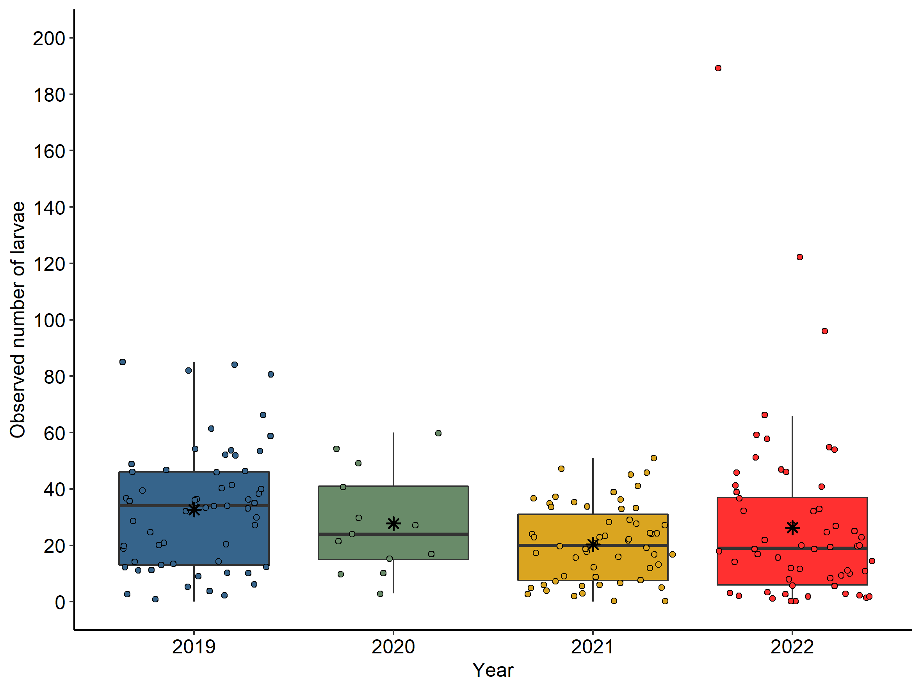
Supplementary Figure S1. Observed number of larvae across all sample sites (excluding KoB) during the monitoring events in 2019, 2020 and 2021 and 2022. The box plots are representing the upper and lower quartile (upper/lower edge of the box), the median (black horizontal line within the box), and the maximum and minimum values (end of upper/lower whisker) lying within 1.5 times the interquartile range. Data points that are >1.5 times the interquartile range (upper quartile–lower quartile) are defined as outliers. Note that the number of monitoring events varied between the years.

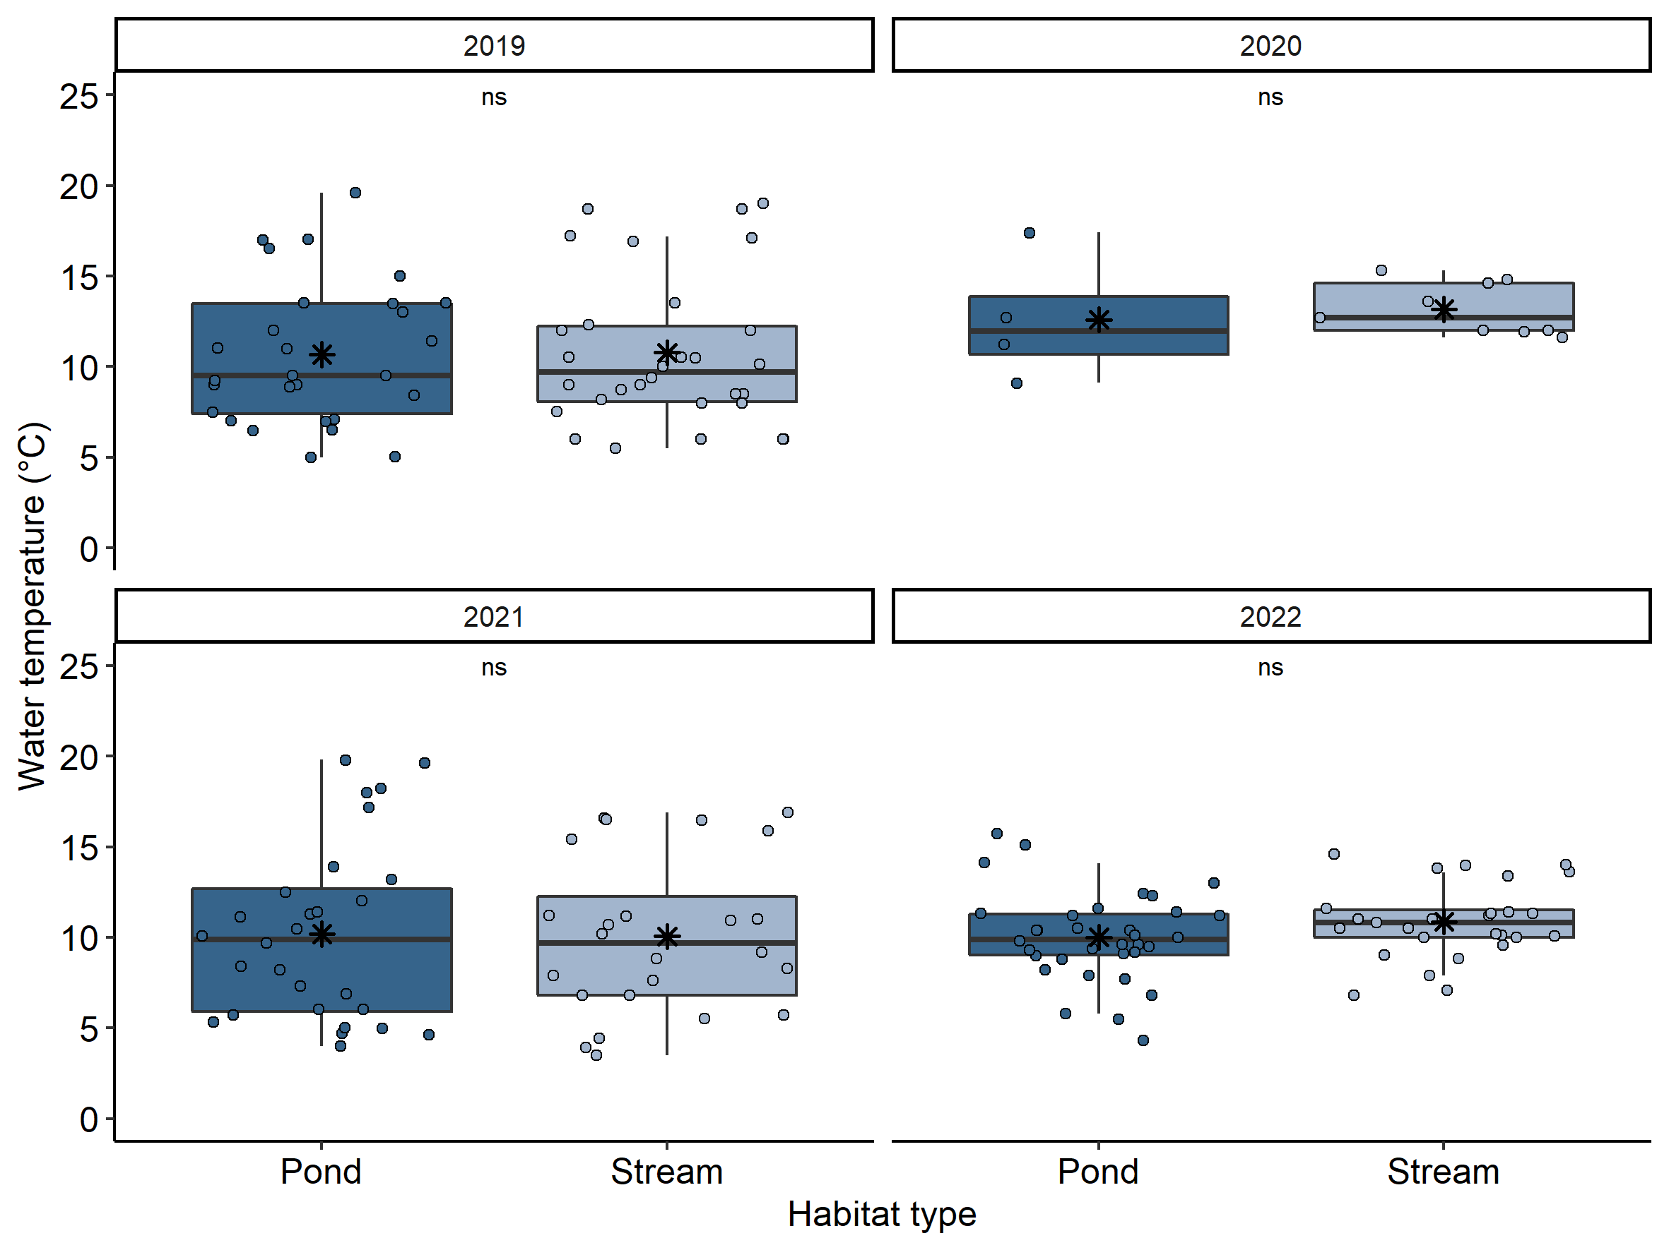

Supplementary Figure S2. Water temperature per habitat type across all sample sites (excluding KoB) during the monitoring events in 2019, 2020 and 2021 and 2022. The box plots are representing the upper and lower quartile (upper/lower edge of the box), the median (black horizontal line within the box), and the maximum and minimum values (end of upper/lower whisker) lying within 1.5 times the interquartile range. Data points that are >1.5 times the interquartile range (upper quartile–lower quartile) are defined as outliers. The annotation above the box plot represents possible differences of the percentage of injured larvae between the two habitat types based on p-values; ns = non-significant.

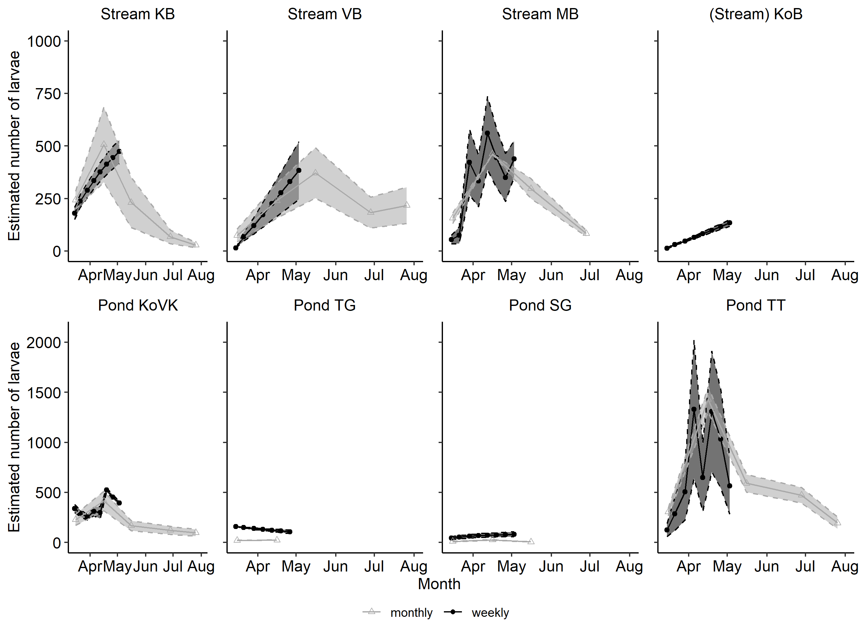

Supplementary Figure S3. Larval population size estimates across all sample sites in the Kottenforst based on weekly (dark grey) and monthly (light grey) monitoring events in 2021. The upper row represents the estimated number of larvae for the streams, the bottom row represents estimated population sizes for the ponds. Stream KoB is in parentheses, since it has characteristics of both, pond and stream. In many cases, the monthly estimation of population size after July was not possible, since there were no more larvae found. Sample sites KoB, TG and SG desiccated after April and May, respectively.

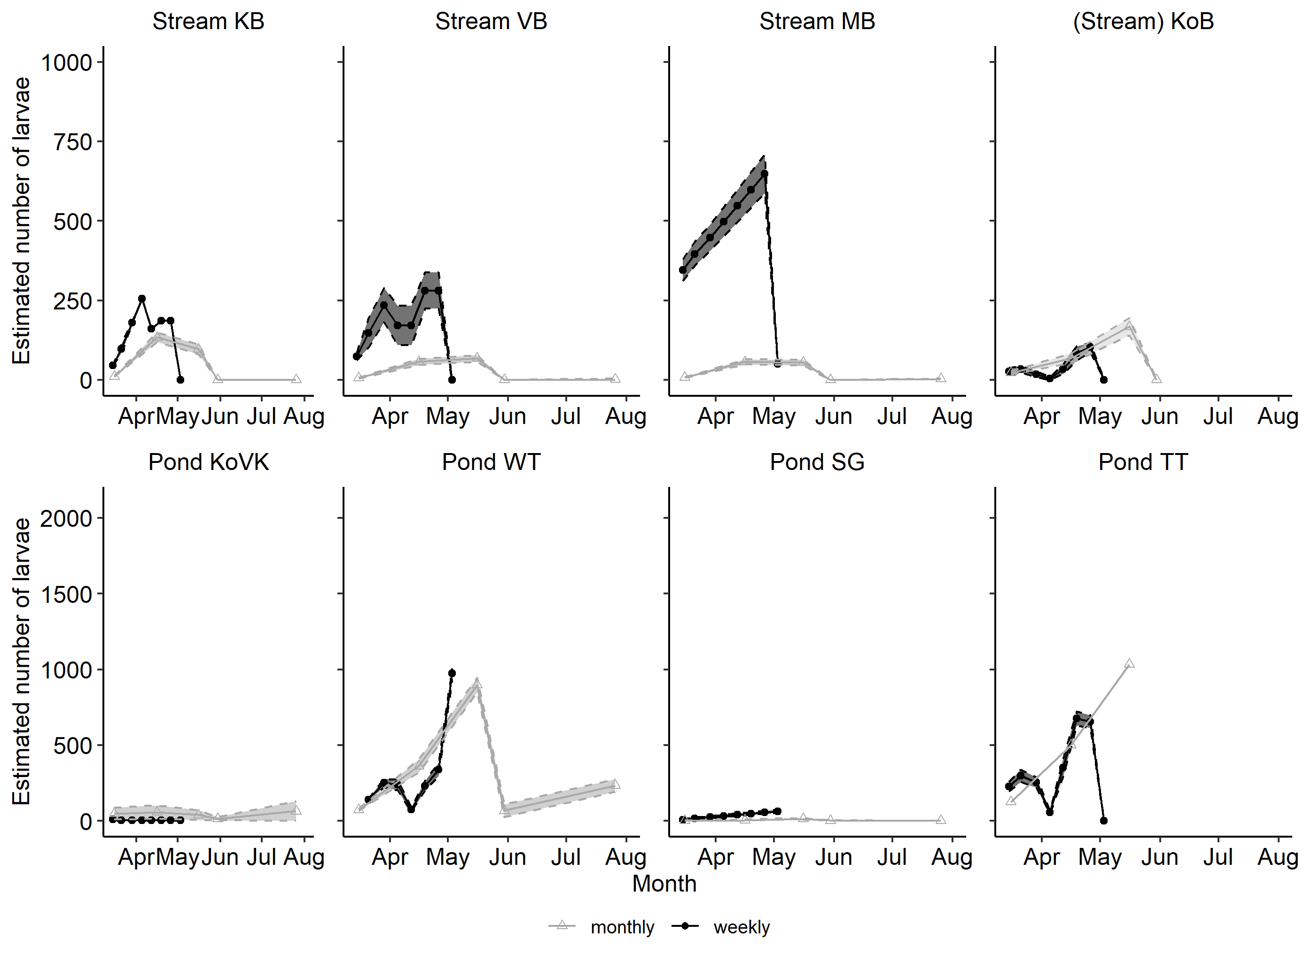

Supplementary Figure S4. Larval population size estimates across all sample sites in the Kottenforst based on weekly (dark grey) and monthly (light grey) monitoring events in 2022. The upper row represents the estimated number of larvae for the streams, the bottom row represents estimated population sizes for the ponds. Stream KoB is in parentheses, since it has characteristics of both, pond and stream. Sample sites KoB and TT desiccated after June and mid-May, respectively.

