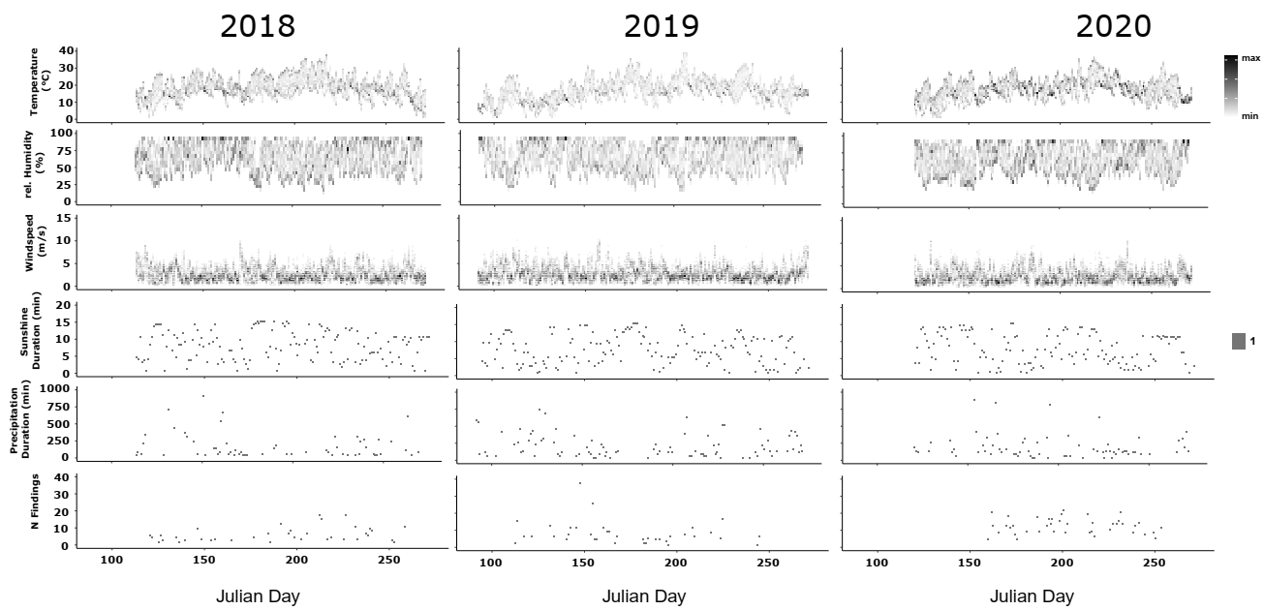

S1. Baseline weather conditions.

S2. Summary statistics of the three climatic variables measured with an infrared laser (temperature of the substrate) and a multimeter (temperature of the air (°C)
and humidity (%).at the direct finding spot in approx. 70 cm above ground.
temp. substrate (ifr) temp. air humidity (%)
min. 13.10 13.90 15.10
1st quantile 24.30 23.70 29.60
median 28.50 26.60 35.40
mean 29.16 26.57 35.77
3rd quantile 33.00 29.60 41.00
max. 54.10 39.50 71.00

S3. Summary statistics of weather data used for statistical analysis comprising current temperature in 5 cm and 200 cm above ground (°C), relative humidity in
200 cm above ground (%), maximum and minimum temperature 200 cm above ground (°C), minimum temperature 5 cm above ground (°C), global radiation (in
joule), sunshine duration (in hours), precipitation duration (in hours), precipitation height (in mm), maximum, minimum and mean windspeed (in m/s), given for
every ten minutes. Source: DWD data server.
temp. temp. rel. max. min. min. global sunshine precip. precip. max. min. mean
200 cm 5 cm hum. temp. temp. temp. radiation dura- dura- height wind- wind- wind-
200 cm 200 cm 200 cm 5 cm (joule) tion tion speed speed speed
min. 8.80 8.60 19.50 9.00 8.80 8.60 0.00 0.00 0.00 0.00 1.00 0.00 0.60
1st quantile 20.30 22.50 38.95 20.55 19.70 22.05 21.40 0.03 0.00 0.00 4.10 0.50 2.50
median 23.00 26.70 44.50 23.30 22.70 26.10 34.20 0.15 0.00 0.00 5.70 1.50 3.40
mean 23.14 26.31 45.21 23.39 22.70 25.82 33.94 0.11 0.42 0.00 5.82 1.61 3.63
3rd quantile 26.10 29.70 51.40 26.60 25.90 29.30 48.40 0.17 0.00 0.00 7.20 2.20 4.50
max. 39.30 43.70 84.60 40.00 39.00 43.70 62.60 0.17 10.00 0.96 15.10 5.70 10.90

S4. Generalized linear Model (GLM) summary statistics performed for distance Principal components
(PCs) depending on all weather PC's, microclimate PC’s, microhabitat structure PC’s, time in minutes
since the first encounter (tsz), calendar week (CW) and julian date.
dependent variable independent estimate standard t-value PR(>|t|)
variable error
distPC1 weatherPC1 0.010 0.012 0.857 0.392
weatherPC2 -0.009 0.022 -0.412 0.681
weatherPC3 -0.034 0.028 -1.2 0.231
weatherPC4 -0.024 0.067 -0.357 0.721
weatherPC5 0.003 0.083 0.034 0.973
weatherPC6 -0.074 0.126 -0.593 0.554
mic_climPC1 0.088 0.143 0.616 0.538
mic_climPC2 -0.088 0.188 -0.467 0.641
mic_strucPC1 0.036 0.157 0.229 0.819
mic_strucPC2 0.191 0.193 0.991 0.322
mic_strucPC3 0.098 0.196 0.5 0.617
tsz 0.000 0.000 -2.288 0.022*
CW 0.053 0.827 0.064 0.949
julian_date 0.004 0.119 0.034 0.973
distPC2 weatherPC1 0.004 0.007 0.541 0.589
weatherPC2 -0.010 0.012 -0.806 0.420
weatherPC3 0.023 0.016 1.454 0.146
weatherPC4 0.006 0.037 0.15 0.881
weatherPC5 0.102 0.046 2.222 0.027*
weatherPC6 -0.015 0.070 -0.209 0.835
mic_climPC1 -0.046 0.079 -0.582 0.561
mic_climPC2 -0.115 0.104 -1.105 0.269
mic_strucPC1 -0.159 0.087 -1.831 0.067
mic_strucPC2 0.037 0.107 0.35 0.726
mic_strucPC3 -0.045 0.108 -0.412 0.681
tsz 0.000 0.000 2.23 0.026*
KW -0.043 0.458 -0.094 0.925
julian_date -0.005 0.066 -0.071 0.944
distPC3 weatherPC1 -0.014 0.005 -2.796 0.005**
weatherPC2 -0.007 0.009 -0.715 0.475
weatherPC3 -0.015 0.012 -1.279 0.201

weatherPC4 -0.013 0.029 -0.447 0.655
weatherPC5 -0.006 0.035 -0.168 0.867
weatherPC6 0.117 0.053 2.199 0.028*
mic_climPC1 -0.057 0.061 -0.934 0.350
mic_climPC2 -0.003 0.080 -0.032 0.975
mic_strucPC1 0.047 0.067 0.699 0.485
mic_strucPC2 0.045 0.082 0.547 0.585
mic_strucPC3 0.043 0.083 0.517 0.605
tsz 0.000 0.000 -0.632 0.528
KW -0.180 0.351 -0.514 0.607
julian_date 0.024 0.050 0.48 0.631
distPC4 weatherPC1 -0.006 0.004 -1.604 0.109
weatherPC2 -0.010 0.007 -1.553 0.121
weatherPC3 0.007 0.009 0.767 0.444
weatherPC4 0.013 0.020 0.657 0.512
weatherPC5 0.012 0.025 0.496 0.620
weatherPC6 -0.013 0.038 -0.355 0.722
mic_climPC1 -0.023 0.043 -0.541 0.588
mic_climPC2 -0.074 0.057 -1.306 0.192
mic_strucPC1 0.012 0.047 0.245 0.807
mic_strucPC2 -0.057 0.058 -0.972 0.331
mic_strucPC3 0.050 0.059 0.854 0.393
tsz 0.000 0.000 -0.616 0.538
KW 0.136 0.250 0.544 0.587
julian_date -0.020 0.036 -0.548 0.584
distPC5 weatherPC1 0.004 0.002 1.774 0.076
weatherPC2 -0.001 0.004 -0.173 0.862
weatherPC3 -0.006 0.005 -1.152 0.250
weatherPC4 0.008 0.012 0.674 0.500
weatherPC5 0.012 0.015 0.822 0.411
weatherPC6 -0.028 0.023 -1.243 0.214
mic_climPC1 -0.052 0.026 -2.027 0.043*
mic_climPC2 0.032 0.034 0.962 0.336
mic_strucPC1 0.039 0.028 1.383 0.167 mic_strucPC2 0.030 0.035 0.856 0.392 mic_strucPC3 0.003 0.035 0.090 0.928 tsz 0.000 0.000 2.043 0.041* KW -0.357 0.148 -2.405 0.016* julian_date 0.052 0.021 2.436 0.015*

S5. Generalized linear Model (GLM) summary statistics performed for microhabitat structure Principal
components (PCs) depending on all microclimate PC’s, time in minutes since the first encounter (tsz),
calendar week (CW) and julian date.
dependent independent estimate standard error t-value PR(>t)
variable variable
mic_strucPC1 mic_climPC1 0.013 0.029 0.450 0.653
mic_climPC2 -0.126 0.039 -3.238 0.001**
tsz 0.000 0.000 -1.357 0.175
KW 0.189 0.165 1.142 0.254
julian_date -0.030 0.024 -1.292 0.197
mic_strucPC2 mic_climPC1 -0.025 0.024 -1.036 0.300
mic_climPC2 -0.001 0.032 -0.019 0.985
tsz 0.000 0.000 -2.108 0.035*
KW -0.315 0.135 -2.328 0.020*
julian_date 0.038 0.019 1.951 0.051
mic_strucPC3 mic_climPC1 -0.063 0.023 -2.683 0.007**
mic_climPC2 0.047 0.031 1.520 0.129
tsz 0.000 0.000 1.049 0.294
KW 0.052 0.133 0.392 0.695
julian_date -0.013 0.019 -0.668 0.504

S6. Generalized linear Model (GLM) summary statistics performed for significant outcomes of the
distance GLMs and computed R-squared when PR(>|t|) values were still significant. * p < 0.05 and ** p <
0.01
dependent independent estimate standard t-value PR(>|t|) R-
variable variable error squared
distPC1 tsz 0.000 0.000 -2.162 0.031* 0.005
distPC2 weatherPC5 0.104 0.045 2.308 0.021* 0.006
tsz 0.000 0.000 2.032 0.042* 0.004
distPC3 weatherPC1 -0.013 0.005 -2.621 0.009** 0.007
weatherPC6 0.120 0.052 2.292 0.022* 0.006
distPC5 mic_climPC1 -0.045 0.025 -1.801 0.072 -
tsz 0.000 0.000 1.717 0.086 -
KW 0.001 0.007 0.147 0.883 -
julian_date 0.001 0.001 0.247 0.805 -
S7. Generalized linear Model (GLM) summary statistics performed again for significant outcomes of the
microhabitat structure GLMs and computed R-squared when PR(>|t|) values were still significant. * p <
0.05 and ** p < 0.01 and *** p < 0.005
dependent independent estimate standard t-value PR(>|t|) R-squared
variable variable error
mic_strucPC1 mic_climPC2 -0.093 0.038 -2.468 0.014* 0.006
mic_strucPC2 tsz 0.000 0.000 -4.797 0.000*** 0.024
KW -0.056 0.007 -8.340 0.000*** 0.069
mic_strucPC3 mic_climPC1 -0.060 0.024 -2.537 0.011* 0.007

