**Supplementary document 1**. Detailed methods and results of mtDNA sequencing and Assemble Species by Automatic Partitioning.

We sequenced a fragment of the mitochondrial 16S rRNA of one adult frog from the captive colony (unnumbered specimen at Trier University; GenBank accession number PP835395). DNA was extracted from muscle tissue using the DNeasy Blood and Tissue Kit (Qiagen, Hilden, Germany). For amplification, we used the primers 16SA-L (5' - CGC CTG TTT ATC AAA AAC AT - 3') and 16SB-H (5' - CCG GTC TGA ACT CAG ATC ACG T - 3') (Vences et al. 2005). We performed PCR in 10 µl reactions using TaqManTM Multiplex Master Mix (Thermo Fisher Scientific, Waltham, Massachusetts, USA) and purified PCR products using the High Pure PCR Product Purification Kit (Roche, Mannheim, Germany). Purified amplicons were sequenced at Macrogene Europe (Amsterdam, Netherlands). Obtained sequences were edited and aligned with sequences downloaded from GenBank using MEGA 11.

The final alignment contained 529 positions. To test if both Ecuadorian and Peruvian specimens morphologically allocable to *Hyloxalus nexipus* comprise the same taxon, we applied the molecular-based species delimitation method Assemble Species by Automatic Partitioning (ASAP; Puillandre et al. 2021). For this purpose, we obtained data from GenBank for 15 *Hyloxalus* samples and dendrobatid outgroups (Table S1). We ran ASAP directly on the web server (https://bioinfo.mnhn.fr/abi/public/asap/asapweb.html; 8 June 2023) using a simple distance model and default parameters. Our sequence was nested within available sequences of *H. nexipus* with both all Ecuadorian and Peruvian material supported as a single taxon in ASAP.

**Table S1.** GenBank samples and their accession numbers used in this study.

|  |  |
| --- | --- |
| Sequence name as in Figure S1 | GenBank accession code |
| *Epipedobates_anthonyi* | KY407884.1 |
| *Phyllobates_terribilis* | EU342639.1 |
| *Hyloxalus_yasuni* | MF624236.1 |
| *Hyloxalus_sauli* | EU342696.1 |
| *Hyloxalus_maculosus* | HQ286384.1 |
| *Hyloxalus_nexipus*_road_Tarapoto_Yurimaguas | this study; PP835395 |
| *Hyloxalus_nexipus*_Cataratas_Ahuashiyacu_A | DQ502016.1 |
| *Hyloxalus_nexipus*_Cataratas_Ahuashiyacu_B | EU342712.1 |
| *Hyloxalus_nexipus*_Cataratas_Ahuashiyacu_C | EU342713.1 |
| *Hyloxalus_nexipus*_Tarapoto | EU342714.1 |
| *Hyloxalus_nexipus*_6km_ESE_Shapaja | EU342711.1 |
| *Hyloxalus_nexipus*_EC_Indanza | EU342709.1 |
| *Hyloxalus_nexipus*_EC_Mendez | EU342710.1 |
| *Hyloxalus_vertebralis* | AY364564.1 |
| *Hyloxalus_pulchellus*_Yanuyaco | EU342722.1 |
| *Hyloxalus_pulchellus*_Rio_Azuela | EU342720.1 |
| *Hyloxalus_toachi* | EU342744.1 |
| *Hyloxalus_awa* | EU342743.1 |

We built a maximum likelihood-based phylogenetic tree in IQ-TREE version 2.0.3 (Minh et al. 2020) using ModelFinderPlus (-m MFP; Kalyaanamoorthy et al. 2017) with 100,000 ultrafast bootstrap replicates (-bb 100000; Hoang et al. 2018) and 100,000 replicates of the SH-like approximate likelihood ratio test (-alrt 100000; Guindon et al. 2010). All *Hyloxalus nexipus* samples formed a clearly monophyletic assemblage.

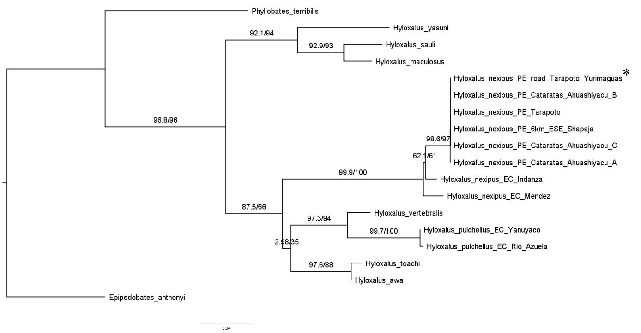

**Figure S1.** Maximum likelihood tree for *Hyloxalus nexipus* including samples from both localities from where tadpoles were studied (i.e. *Hyloxalus_nexipus*_EC_Mendez and *Hyloxalus_nexipus*_PE_  
road_Tarapoto_Yurimaguas). The sequence from this study is indicated by an asterisk. Branch values show Ultrafast Bootstrap values and SH-like approximate likelihood ratio test values.

The first partition provided by ASAP had an Asap-Score of 1.500000 and a probability of 2.614770*e-1. ASAP found 8 subsets in the alignment as follows (names as in Fig. S1):

Subset[ 1 ] n: 8 ;id:

*Hyloxalus_nexipus*_PE_road_Tarapoto_Yurimaguas *Hyloxalus_nexipus*_PE_Cataratas_Ahuashiyacu_A

*Hyloxalus_nexipus*_PE_Tarapoto

*Hyloxalus_nexipus*_PE_6km_ESE_Shapaja *Hyloxalus_nexipus*_PE_Cataratas_Ahuashiyacu_B *Hyloxalus_nexipus*_PE_Cataratas_Ahuashiyacu_C

*Hyloxalus_nexipus*_EC_Mendez Hyloxalus_nexipus_EC_Indanza

Subset[ 2 ] n: 1 ;id:

*Phyllobates_terribilis*

Subset[ 3 ] n: 1 ;id:

*Hyloxalus_yasuni*

Subset[ 4 ] n: 1 ;id:

*Hyloxalus_vertebralis*

Subset[ 5 ] n: 2 ;id:

*Hyloxalus_pulchellus*_EC_Yanuyaco

*Hyloxalus_pulchellus*_EC_Rio_Azuela

Subset[ 6 ] n: 2 ;id:

*Hyloxalus_toachi*

*Hyloxalus_awa*

Subset[ 7 ] n: 1 ;id:

*Epipedobates_anthonyi*

Subset[ 8 ] n: 2 ;id:

*Hyloxalus_sauli*

*Hyloxalus_maculosus*

**References**

Guindon, S., J.-F. Dufayard, V. Lefort, M. Anisimova, W. Hordijk & O. Gascuel (2010): New algorithms and methods to estimate maximum-likelihood phylogenies: Assessing the performance of PhyML 3.0. – Systematic Biology, **59**: 307–321.

Hoang, D. T., O. Chernomor, A. von Haeseler, B. Q. Minh & L. S. Vinh (2018): UFBoot2: Improving the ultrafast bootstrap approximation. – Molecular Biology and Evolution, **35**: 518–522.

Kalyaanamoorthy, S., B. Q. Minh, T. K. F. Wong, A. von Haeseler, L. S. Jermiin (2017): ModelFinder: Fast model selection for accurate phylogenetic estimates. – Nature Methods, **14**: 587–589.

Minh, B. Q., H. A. Schmidt, O. Chernomor, D. Schrempf, M. D. Woodhams, A. van Haeseler & R. Lanfear (2020): IQ-TREE 2: New models and efficient methods for phylogenetic inference in the genomic era. – Molecular Biology and Evolution, **37**: 1530–1534.

Puillandre, N., S. Brouillet & G. Achaz (2020): ASAP: assemble species by automatic partitioning. – Molecular Ecology Resources, **21**: 609–620.

Vences, M., M. Thomas, A. van der Meijden, Y. Chiari & D. R. Vieites (2005): Comparative performance of the 16S rRNA gene in DNA barcoding of amphibians. – Frontiers in Zoology, **2**: 5.