Multiplex 1 | Volume (µl)
RlCA1b5 F+R (10 µM) | 0,1
Ga1a19 F+R (10 µM) | 0,2
RlCA2a34 F+R (10 µM) | 0,2
Rrid013A F+R (10 µM) | 0,2
Res17 F+R (10 µM) | 0,2
Rrid064A F+R (10 µM) | 0,2
Type-it Microsatellite PCR Kit | 5
Q-Solution | 2
ddH2O | 0,9
DNA | 1
Multiplex 2 | Volume (µl)
Re1Caga10 F+R (10 µM) | 0,2
Ress22 F+R (10 µM) | 0,1
RlCA18 F+R (10 µM) | 0,2
Rrid082A F+R (10 µM) | 0,2
Rrid169A F+R (10 µM) | 0,2
RlCA1b6 F+R (10 µM) | 0,2
Type-it Microsatellite PCR Kit | 5
Q-Solution | 2
ddH2O | 0,9
DNA | 1
Multiplex 3 | Volume (µl)
RICA5 F+R (10 µM) | 0,1
Ga1a23 F+R (10 µM) | 0,1
Rrid059A F+R (10 µM) | 0,1
RlCA1a27 F+R (10 µM) | 0,1
Rrid135A F+R (10 µM) | 0,1
Pper3.22 F+R (10 µM) | 0,1
Type-it Microsatellite PCR Kit | 5
ddH2O | 3,4
DNA | 1
Table S1. The composition of three multiplex PCR mixtures for microsatellite amplification.

Table S2. Species-specific loci and alleles of three representatives of the Pelophylax esculentus complex.
Locus | P. lessonae | P. ridibundus | L genome in P. esculentus | R genome in P. esculentus
GA1A19 | 96 | 103, 107, 109, 119, 121, 125, 140, 145, 147, 149, 151, 153, 155 | 96 | 103, 107, 119, 149, 151, 155, 157, 160
Re1Caga10 | - | 91, 95, 104, 108, 110, 113, 115, 117, 119, 121, 123, 131, 147 | - | 95, 104, 108, 110, 113, 115, 121
RlCA 18 | 169, 171, 175, 177, 179, 181, 185, 190, 202 | - | 169, 171, 173, 175, 177, 179, 181, 185, 187, 190, 202 | -
RlCA2a34 | 109, 127, 132, 134, 136, 140, 142, 145, 149, 151, 159, 174 | - | 109, 111, 127, 132, 134, 136, 138, 140, 142, 145, 147, 149, 151 | -
Rrid169A | - | 181, 183, 185, 187, 189, 193, 199, 201, 205, 207, 208 | - | 185, 187, 189, 208
RlCA1b5 | 118, 120 | 129, 131, 133 | 118, 120 | 133
Rrid064A | - | 207, 221, 223 | - | 221, 230
Res22 | - | 81, 89, 109, 115, 117, 123, 129, 131 | - | 109, 129
Rrid082A | - | 160, 162, 164, 166, 169, 171, 175, 177, 179,188, 190 | - | 175, 177
Res17 | - | 156, 168 | - | 156, 168
Rrid013A | 288, 294, 297, 300 | 283, 288, 291 | 283, 288, 291, 294, 297, 300 | 283, 288
RlCA1b6 | 81, 83 | 81, 85, 87, 90, 92, 94, 96, 100 | 81, 83 | 81, 85, 94, 96
RlCA 5 | 234, 245, 251, 253, 257, 259, 261 | - | 234, 245, 247, 253, 257, 259, 261, 263, 267 | -
Ga1a23 | 117, 121, 123, 125, 127, 129, 133, 138 | - | 109, 115, 117, 119, 121, 123, 125, 127, 129, 131, 133, 135, 138, 141 | -
Rrid059A | 101 | 128, 131, 133, 135, 136, 137, 139, 141, 143, 146 | 101, 133 | 133, 136
RlCa1a27 | 89, 101, 105, 108, 112, 114 | - | 89, 101, 105, 106, 108, 110, 112, 114, 116 | -
Rrid135A | - | 172, 203, 206, 207, 221, 223, 226, 241, 256 | - | 203, 207, 221
Pper3.22 | - | 343, 348, 354, 357 | - | 343, 354, 357

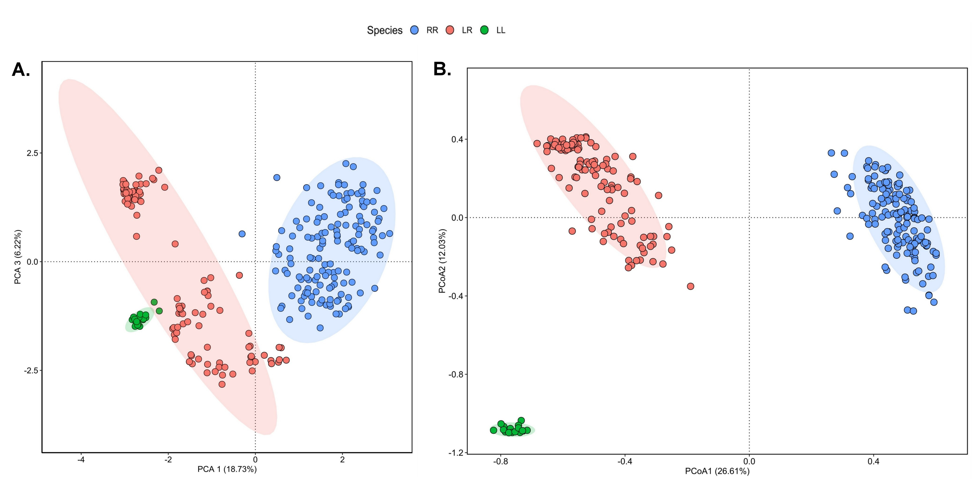

Figure S1. Multivariate analyses of water frogs based on microsatellite data. A. Principal component analysis (PCA) analysis, B. Principal coordinates analysis (PCoA). RR – Pelophylax ridibundus, LR – P. esculentus, LL – P. lessonae.

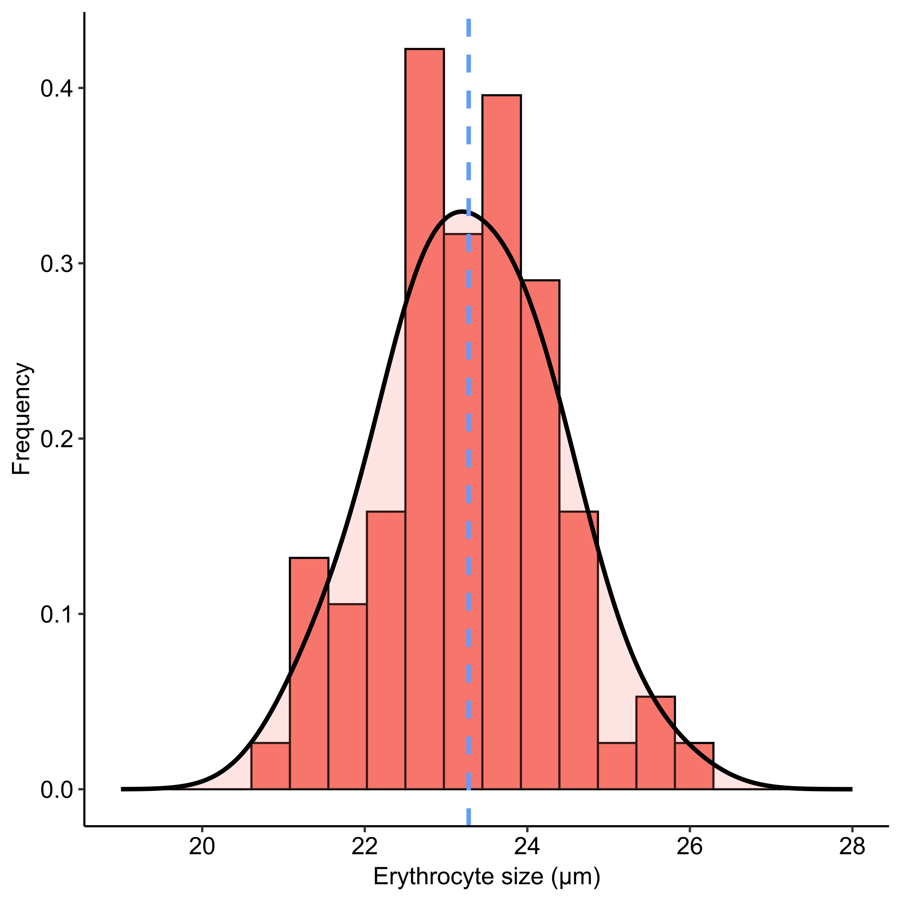

Figure S2. A histogram showing the frequency of Pelophylax esculentus individuals in a particular erythrocyte size category. Blue dashed line indicates mean value.

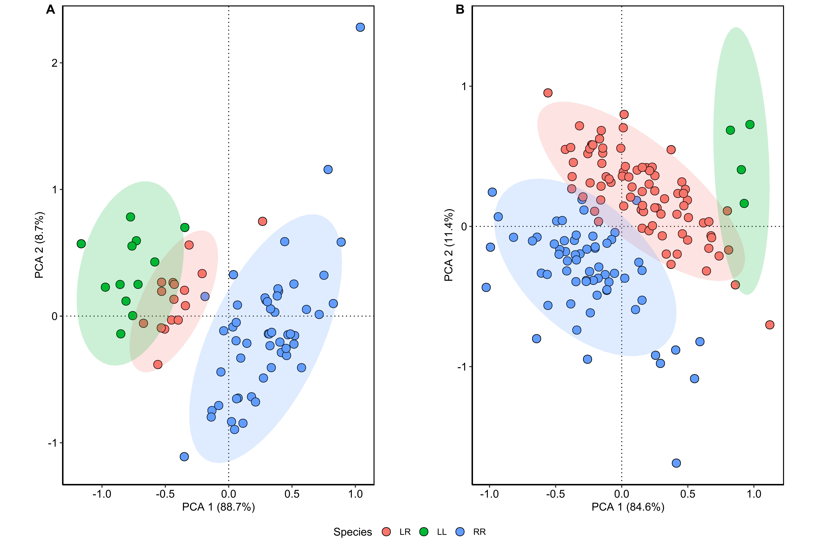
Figure S3. Multivariate principal component analysis (PCA) analysis of water frog males (A) and females (B) based on morphometric data. RR – Pelophylax ridibundus, LR – P. esculentus, LL – P. lessonae.

