Online supplementary data – Ernesto Castillo-Urbina et al.: New insights into the diversity of Oreobates frogs (Anura: Craugastoridae): description of a new species from the Peruvian Yungas and comments on O. quixensis and O. saxatilis. – Salamandra, 61 (4): 423–441.

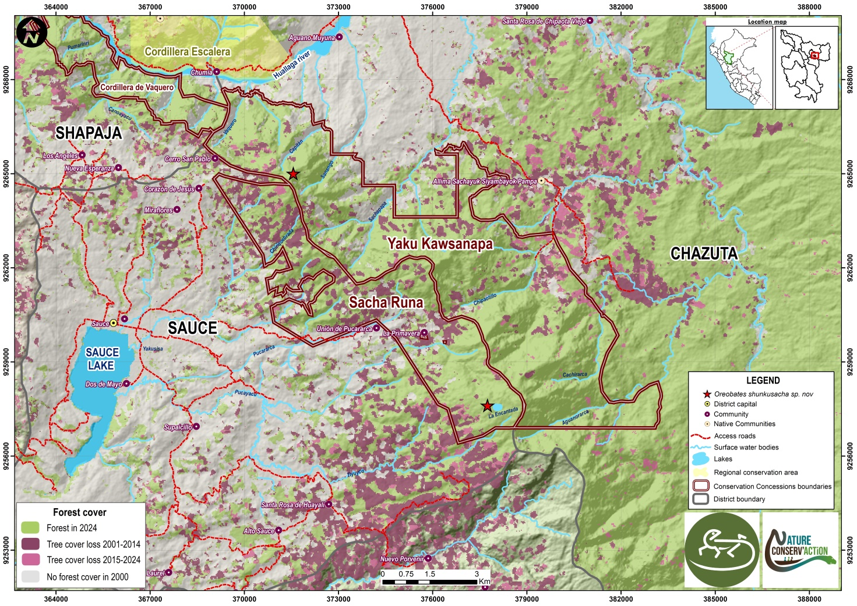
Figure S1. Map of forest cover loss within the Biocorredor Bosques de Vaquero 'Shunku Sacha', Shapaja, Chazuta, and Sauce Districts, San Martín Province, San Martín Department, Peru. Red stars indicate the positions of Oreobates shunkusacha sp. n. localities. Polygons with brown boundaries indicate the boundaries of the Conservation Concession Cordillera de Vaquero, Yaku Kawsanapa, and Sacha Runa. Green areas represent forest cover in 2024, dark purple areas indicate forest loss from 2001 to 2014, and light purple areas indicate forest loss from 2015 to 2024.

