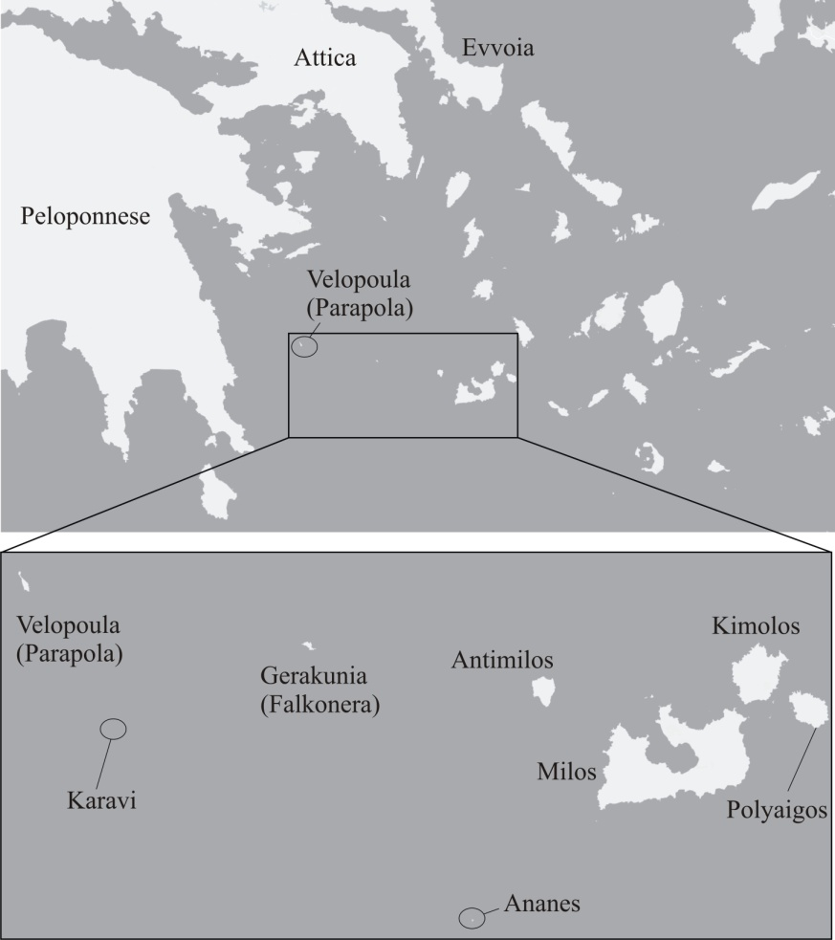

**Supplementary** **Figure S1.** Map of the islands constituting the Milos island –group and their position in the Aegean.



**Supplementary** **Figure S2.** Chronogram of the combined mitochondrial sequences obtained with BEAST analysis including one representative *Podarcis erhardii* per “species”, as delimited with mPTP, and closely related *Podarcis* taxa that were used in order to root and to calibrate the phylogeny (*P. muralis, P. milensis, P. cretensis* and *P. peloponnesiacus*). Numbers on each node give the respective time‐estimation as the mean value, bars represent the 95% HPD intervals [min–max] and correspond to the scale in million years at the bottom of the graphic. Numbers in italics show the respective nodal support (posterior probability values).

suppl_FigS2.TIF

**Supplementary** **Figure S3.** Palaeogeographic reconstruction of the focal region during the Messinian (late Miocene) and the early Pliocene periods (Anastasakis et al., 2006). The approximate position of Velopoula is marked with an arrow.

**Supplementary** **Table S1.** List of specimens analyzed in this study. Specimen working codes and the respective collection localities are given in accordance with Figure 1. GenBank Accession Numbers for the sequences are provided. Working codes for specimens collected during this work are also the voucher numbers of the respective tissue-samples that have been deposited in the collections of the Zoological Museum of the University of Patras (ZMUP).

|  |  |  |  |  |
| --- | --- | --- | --- | --- |
| **Working Code** | **Species** | **Locality** | ***cytb*** | ***16S*** |
| **Sequences produced here** | | | | |
|  |  |  |  |  |
| 322 | *Podarcis erhardii* | Geraneia Mt. east Attica | PQ591863 | PQ567217 |
| 372 | *Podarcis erhardii* | Mikri Vigla, Naxos isl. | PQ591864 | PQ567218 |
| 406 | *Podarcis erhardii* | Dam, Serifos isl. | PQ591865 | PQ567219 |
| 415 | *Podarcis erhardii* | Kolibithra, Tinos isl. | n.a. | PQ567220 |
| 500 | *Podarcis erhardii* | Geraneia Mt. east Attica | PQ591866 | PQ567221 |
| 501 | *Podarcis erhardii* | Geraneia Mt. east Attica | PQ591867 | PQ567222 |
| 502 | *Podarcis erhardii* | Geraneia Mt. east Attica | PQ591868 | PQ567223 |
| 546 | *Podarcis erhardii* | Feneos lake, Peloponnese | PQ591869 | PQ567224 |
| 547 | *Podarcis erhardii* | Feneos lake, Peloponnese | PQ591870 | PQ567225 |
| 548 | *Podarcis erhardii* | Feneos lake, Peloponnese | PQ591871 | PQ567226 |
| 553 | *Podarcis erhardii* | Karystos, Evvoia | PQ591872 | PQ567227 |
| 554 | *Podarcis erhardii* | Karystos, Evvoia | PQ591873 | PQ567228 |
| 556 | *Podarcis erhardii* | Paradisi, Evvoia | PQ591874 | PQ567229 |
| 624 | *Podarcis erhardii* | Velopoula islet | PQ591875 | PQ567230 |
| 625 | *Podarcis erhardii* | Velopoula islet | PQ591876 | PQ567231 |
| 626 | *Podarcis erhardii* | Velopoula islet | PQ591877 | PQ567232 |
| 627 | *Podarcis erhardii* | Velopoula islet | PQ591878 | PQ567233 |
| 628 | *Podarcis erhardii* | Velopoula islet | PQ591879 | PQ567234 |
| 629 | *Podarcis erhardii* | Velopoula islet | PQ591880 | PQ567235 |
| 630 | *Podarcis erhardii* | Velopoula islet | n.a. | PQ567236 |
| 631 | *Podarcis erhardii* | Velopoula islet | PQ591881 | PQ567237 |
| 635 | *Podarcis erhardii* | Stefania islet | PQ591882 | PQ567238 |
|  |  |  |  |  |
| **Sequences retrieved from GenBank** | | | | |
| ***From Poulakakis et al. (2003) and Poulakakis et al. (2005) - Working codes and information as presented therein*** | | | | |
|  | | | | |
| 48 | *P. e. riveti* | Makedonia (Grevena) | AY896059 | AY896195 |
| 49 | *P. e. thessalica* | Evoia (Kryoneritis) | AY896060 | AY896196 |
| 50 | *P. e. thessalica* | Thessalia (Plastira) | AY896061 | AY896197 |
| 51 | *P. e. thessalica* | Thessalia (Sarantaporos) | AY896062 | AY896198 |
| 52 | *P. e. riveti* | Sterea Ellada (Gkiona) | AY896064 | AY896199 |
| 55 | *P. e. riveti* | Makedonia (Sidironero) | AY896087 | AY896202 |
| 57 | *P. e. riveti* | Serbia (Gostivach) | AY896070 | AY896204 |
| 60 | *P. e. riveti* | Serbia (Makrovi) | AY896073 | AY896207 |
| 61 | *P. e. riveti* | Skopje (Tettovo) | AY896075 | AY896208 |
| 67 | *P. e. riveti* | Skopje (Oxrida) | AY896083 | AY896214 |
| 70 | *P. e. ruthveni* | N Sporades (Alonisos isl.) | AY896091 | AY896217 |
| 71 | *P. e. ruthveni* | N Sporades (Gioura isl.) | AY896092 | AY896218 |
| 72 | *P. e. ruthveni* | N Sporades (Skopelos isl.) | AF486230 | AY896219 |
| 75 | *P. e. syrinae* | Cyclades (Astypalaia isl.) | AF486223 | AY896222 |
| 79 | *P. e. mykonensis* | Cyclades (Syros isl.) | AY896093 | AY896226 |
| 80 | *P. e. mykonensis* | Cyclades (Tinos isl.) | AY896094 | AY896227 |
| 81 | *P. e. naxensis* | Cyclades (Koufonisi isl.) | AY896096 | AY896228 |
| 82 | *P. e. erhardii* | Cyclades (Serifos isl.) | AY896098 | AY896229 |
| 83 | *P. e. mykonensis* | Cyclades (Mykonos isl.) | AY896099 | AY896230 |
| 84 | *P. e. naxensis* | Cyclades (Ios isl.) | AY896100 | AY896231 |
| 86 | *P. e. megalophthenae* | Cyclades (Meg. Fteno isl.) | AY896103 | AY896233 |
| 87 | *P. e. biinsulicola* | Cyclades (Mikro Fteno isl.) | AY896104 | AY896234 |
| 88 | *P. e. naxensi* | Cyclades (Nea Kameni isl.) | AY896105 | AY896235 |
| 89 | *P. e. naxensi* | Cyclades (Thirasia isl.) | AY896106 | AY896236 |
| 90 | *P. e. naxensis* | Cyclades (Sxoinousa isl.) | AY896107 | AY896237 |
| 91 | *P. e. erhardii* | Cyclades (Sifnos isl.) | AY896108 | AY896238 |
| 92 | *P. e. syrinae* | Cyclades (Dio Adelfia isl.) | AY896110 | AY896239 |
| 93 | *P. e. syrinae* | Cyclades (Syrna isl.) | AY896113 | AY896240 |
| 94 | *P. e. zafranae* | Cyclades (Zofrano isl.) | AY896114 | AY896241 |
| 95 | *P. e. mykonensis* | Cyclades (Andros isl.) | AY896115 | AY896242 |
|  |  |  |  |  |
| ***From Salvi et al. (2021)*** | | | | |
| 3819 | *P. erhardii* | Thirasia islet, Santorini | MW619424 | MW619285 |
|  |  |  |  |  |
| ***From Psonis et al. (2017)*** | | | | |
| 658 | *P. erhardii* | Crnovska River, Serbia | KX657877 | KX658179 |
| 636 | *P. erhardii* | Former Yugoslavian Republic of Macedonia | KX657876 | KX658178 |
|  |  |  |  |  |
| **Outgroups** | | | | |
|  | *P. peloponnesiacus* | ***Psonis et al. (2017)*** | KX657923 | KX658225 |
|  | *P. cretensis* | ***Salvi et al. (2021)*** | MW619422 | MW619283 |
|  | *P. milensis* | ***Psonis et al. (2017)*** | KX657913 | KX658215 |
|  | *P. muralis* | ***Psonis et al. (2017)*** | KX657921 | KX658223 |

**Supplementary** **Table S2.** Primers from Palumbi, 1996 and PCR conditions for the amplification of the mitochondrial markers, cytochrome b (*cytb*) and 16S rRNA (*16S*). Sequencing was performed in Macrogen Europe.

|  |  |  |  |  |
| --- | --- | --- | --- | --- |
| **Marker** | **Primers** | **Primer sequence** | **Product length (bps)** | **PCR- conditions** |
|  |  |  |  | 35 cycles of:  95οC for 5 min |
| *cytb* | GLUDG | 5΄-TGACTTGAARAACCAYCGTTG-3΄ |  | 95οC for 1 min |
| CB2 | 5΄-CCCTCAGAATGATATTGTCCTCA-3΄ | ~500 | *47οC for 1 min or* |
| *16S* | 16SAr-L | 5΄-CGGCCGCCTGTTTATCAAAAACAT-3΄ | ~500 | *55οC for 1 min* |
| 16SBr-H | 5΄-GGAGTCCCGGTTTGAACTCAGATC-3΄ |  | 72οC for 45 sec  (1.5 mM of MgCl2) |

**Supplementary** **Table S3.** Partitions and models used in the respective analyses.

|  |  |  |  |
| --- | --- | --- | --- |
| **Analysis** | **Best partitoniong scheme** | **Best model** | **Reference** |
| Maximum Likelihood – IQTREE | 1st cytb+2nd cytb+3rd cytb+16S  (single partition) | TIM2+F+G | Kalyaanamoorthy et al., 2017 |
| Bayesian Inference – BEAST | 1st cytb+2nd cytb+3rd cytb+16S  (single partition) | TN+FO+G | Tamura & Nei, 1993 |
| Divergence-times estimation – BEAST (reduced dataset – one sequence per “species”) | 1st cytb+2nd cytb+3rd cytb+16S  (single partition) | TN+FO+G | Tamura & Nei, 1993 |

F = Empirical state frequency observed from the data

FO = State frequency optimized by maximum-likelihood from the data

G = Gamma distribution

**Supplementary** **Table S4**. Genetic diversity between pairs of phylogenetic clades retrieved in our analyses, calculated as net uncorrected pairwise *p*-distances (mean values given in %). The lower left diagonal shows values estimated for *cytb* and the upper right one for *16s*, respectively. Values estimated between Velopoula and all other clades, are marked with orange (*cytb*) and green (*16s*).

|  |  |  |  |  |  |  |  |  |  |  |  |
| --- | --- | --- | --- | --- | --- | --- | --- | --- | --- | --- | --- |
| **Clade** | **Genetic distances** | | | | | | | | | | |
| Balkan Peninsula |  | 1.3 | 1.4 | 3.0 | 2.6 | 2.8 | 3.1 | 3.6 | 2.9 | 3.1 | 4.8 |
| Serbia | 4.1 |  | 0.9 | 2.5 | 1.7 | 1.9 | 2.2 | 2.7 | 2.0 | 2.6 | 4.3 |
| Sporades | 4.8 | 5.9 |  | 3.0 | 2.1 | 2.4 | 2.7 | 3.2 | 2.5 | 3.1 | 4.8 |
| Velopoula | 9.8 | 9.7 | 9.7 |  | 2.2 | 2.6 | 2.9 | 3.5 | 2.7 | 4.0 | 5.6 |
| West Cyclades | 10.3 | 9.8 | 10.4 | 7.4 |  | 0.9 | 1.2 | 1.7 | 1.2 | 3.3 | 4.3 |
| South Cyclades | 8.5 | 9.7 | 9.6 | 7.6 | 7.1 |  | 1.2 | 1.5 | 1.5 | 3.9 | 4.4 |
| Central Cyclades | 11.7 | 11.9 | 10.6 | 7.9 | 7.6 | 7.0 |  | 2.0 | 1.6 | 4.2 | 5.2 |
| Peoloponnes & Attica | 9.7 | 10.3 | 9.9 | 6.7 | 5.8 | 6.1 | 5.9 |  | 0.9 | 4.3 | 4.8 |
| South Evvoia | 9.2 | 10.0 | 9.3 | 7.7 | 6.7 | 6.0 | 6.9 | 2.6 |  | 3.6 | 4.5 |
| *Podarcis peloponnesiacus* | 11.9 | 13.7 | 13.1 | 11.5 | 13.1 | 11.8 | 12.4 | 12.8 | 12.8 |  | 3.1 |
| *Podarcis cretensis* | 13.7 | 15.3 | 14.4 | 13.1 | 15.5 | 14.8 | 14.9 | 13.8 | 14.1 | 6.9 |  |

**References**

Anastasakis, G., D. J. W. Piper, M. D. Dermitzakis & V. Karakitsios (2006): Upper Cenozoic stratigraphy and peleogeographic evolution of Myrtoon and adjacent basins, Aegean Sea, Greece. – Marine and Petroleum Geology, **23:** 353 – 369.

Kalyaanamoorthy, S., B. Q. Minh, T. K. F. Wong, A. Von Haeseler & L. S. Jermiin (2017): ModelFinder: fast model selection for accurate phylogenetic estimates. – Nature Methods, **14:** 587 – 589.

Palumbi, S. R. (1996): Nucleic acids II: the polymerase chain reaction. In D.M. Hillis, C. Moritz, B.K. Mable (Eds.), Molecular Systematics (pp. 205-248). – Sinauer Ltd, Sunderland, Masachousette, U.S.A.

Poulakakis, N., P. Lymberakis, A. Antoniou, D. Chalkia, E. Zouros, M. Mylonas & E. Valakos (2003): Molecular phylogeny and biogeography of the wall-lizard *Podarcis erhardii* (Squamata: Lacertidae). – Molecular Phylogenetics and Evolution, **28:** 38 – 46.

Poulakakis, N., P. Lymberakis, E. Valakos, E. Zouros & M. Mylonas (2005): Phylogenetic relationships and biogeography of *Podarcis* species from the Balkan Peninsula, by bayesian and maximum likelihood analyses of mitochondrial DNA sequences. – Molecular Phylogenetics and Evolution, **37:** 845 – 857.

Salvi, D., C. Pinho, J. Mendes & D.J. Harris (2021): Fossil-calibrated time tree of *Podarcis* wall lizards provides limited support for biogeographic calibration models. –Molecular Phylogenetics and Evolution, **161:** 107 – 169.

Psonis, N., A. Antoniou, O. Kukushkin, D. Jablonski, B. Petrov, J. Crnobrnja-Isailovíc, K. Sotiropoulos, I. Gherghel, P. Lymberakis & N. Poulakakis (2017): Hidden diversity in the *Podarcis tauricus* (Sauria, Lacertidae) species subgroup in the light of multilocus phylogeny and species delimitation. – Molecular Phylogenetics and Evolution, **106:** 6 – 17.

Tamura, K. & M. Nei (1993): Estimation of the number of nucleotide substitutions in the control region of mitochondrial DNA in humans and chimpanzees. – Molecular Biology and Evolution, **10:** 512 – 526.